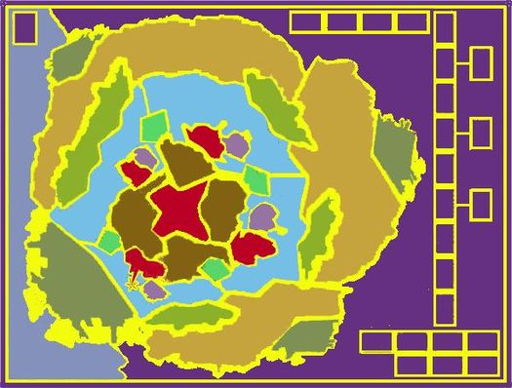

Dum-Bassa City
3rd Army Bde
2nd Army Bde
Central Bank
Southwestern Middle Class Area
Northern Middle Class Neighbourhood
Western Slum
Northwest Slum
West Wood Suburb
University City
4th Police Precinct
U.S.A.
U.K.
Chamber of Deputies
Market
Wealthy Neighbourhood
1st Army Bde
3rd Police Precinct
Mexico
Railway Station
Tracks
South Side Slum
South River Suburb
2nd Police Precinct
1st Police Precinct
Cathedral
East Middle Class Area
Radio Station
Russia
Northern Suburb
East Hill Slum

Dockyards
Presidential Palace

